**SE185: Problem Solving in Software Engineering**

**Quiz #3 (100 points)**

|  |  |
| --- | --- |
| Name: Adam Jennissen | Name: Carter Bebee |

Answer the following questions and make a pdf file that includes the **source code, sample inputs, and outputs**. You must submit the **pdf file and all of the .c files** on Canvas for full credit. Do not forget to add your group partner name on the pdf file and the source codes.

1. **(50 points)** Write a complete C program that ask the user to enter the grading percentage (e.g., any students from SE 185) and print the letter grade. For example, if the student entered 97, your program should output ==> **Your grade letter is** A.

* Make sure that the student is not entering a grade less than 0 or greater than 100.
* You can use our course grading scale which is pasted below or can be found in the syllabus.

**Grading Scale**

93 - 100 = A

90 – less than 93 = A-

++++++++++++++++++++++++++

87 – less than 90 = B+

83 – less than 87 = B

80 – less than 83 = B-

++++++++++++++++++++++++++

77 – less than 80 = C+

73 – less than 77 = C

70 – less than 73 = C-

++++++++++++++++++++++++++

67 – less than 70 = D+

63 – less than 67 = D

60 – less than 63 = D-

++++++++++++++++++++++++++

0 – less than 60 = F

**Inputs and outputs format:**

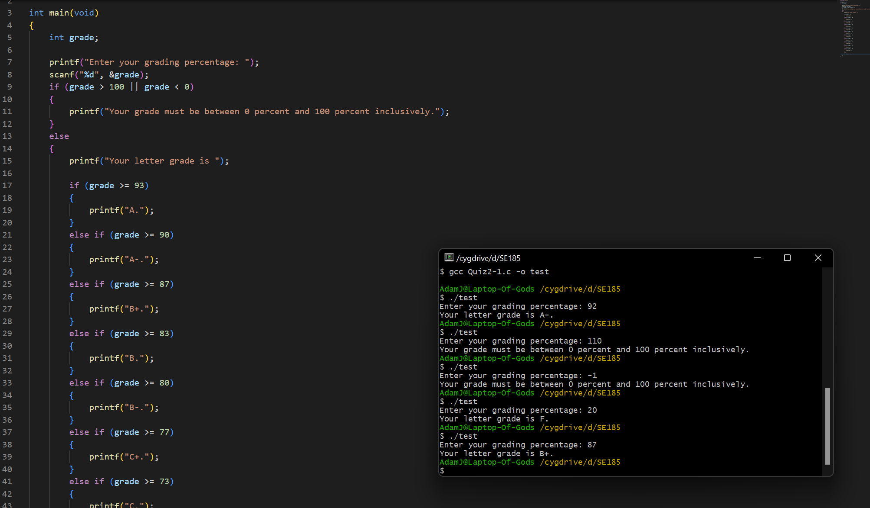

1. **(50 points)** Write a complete C program that asks the user to enter the correct username and password and checks whether the user’s inputs are correct. Let the correct credentials be as follows:

**Username:** se185@iastate.edu

**Password:** ds4rd

If both the user-entered username and password are correct, **print “Success!**” If either the user-entered username and password are incorrect, **print “Username or password is incorrect.”**

**Inputs and outputs format:**

**Test 1:**

**Test 2:**

